NSSA-220 Project 1: Application Performance Monitoring
Baden Joseph, Ivan Shao, Kenny Yang

Introduction

Write a 3-4 sentence introduction that describes what this project was about. Use the project slides as your guide. I want to see you describe the project in your own words.
Project 1 focused on creating and deploying an application performance monitoring (APM) tool using a Bash script to evaluate process and system-level performance. We were given 6 applications as pre-compiled C executables that needed to be spawned by the script in a Rocky Linux VM. By integrating various diagnostic utilities into the script, we were able to track system resources every 5 seconds for 15 minutes. The APM script would collect the output of all process-level CPU and memory metrics, which was then written into CSV files, while overall system metrics were written into a single CSV file.

Process Level Metrics

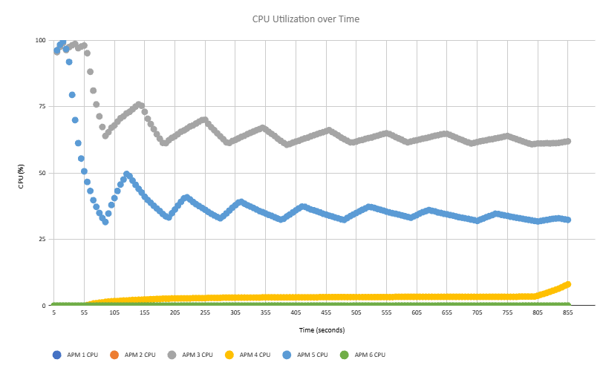

Describe what the CPU utilization plot shows in 2-3 sentences.

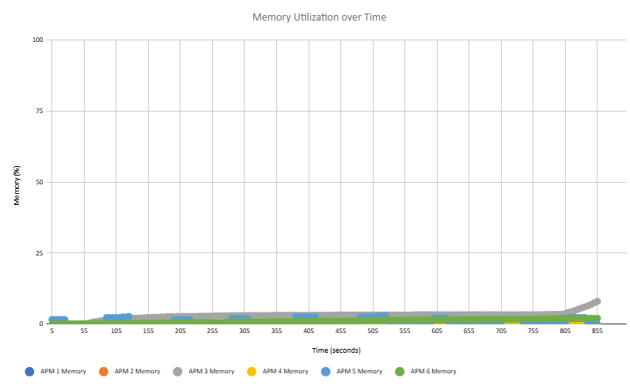

Describe what the memory utilization plot shows in 2-3 sentences.

Potential things to write about: Which processes used the most CPU/memory? Which processes used the least CPU/memory? Did any processes have any interesting patterns in their CPU and/or memory utilization? Could you see a memory leak (memory use that only increased over time) in any of the processes?

System Level Metrics

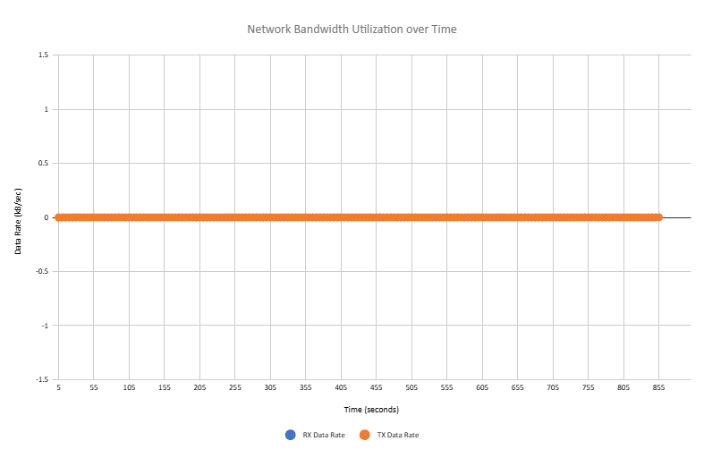

Describe what the network bandwidth utilization plot shows in 2-3 sentences.

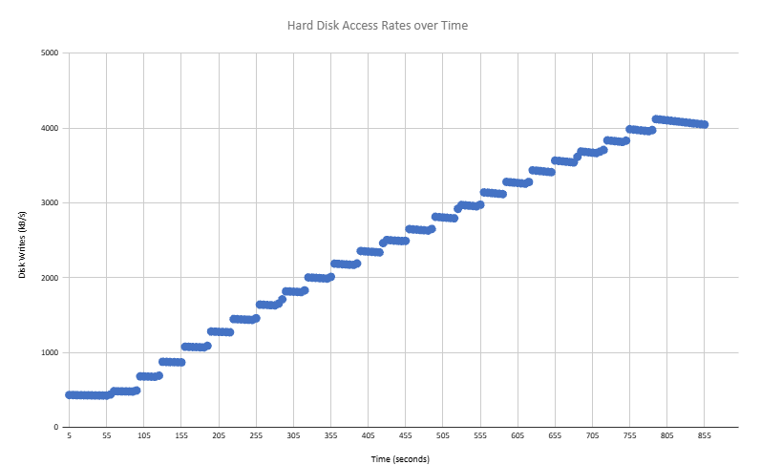

Describe what the hard disk access rates plot shows in 1-2 sentences.

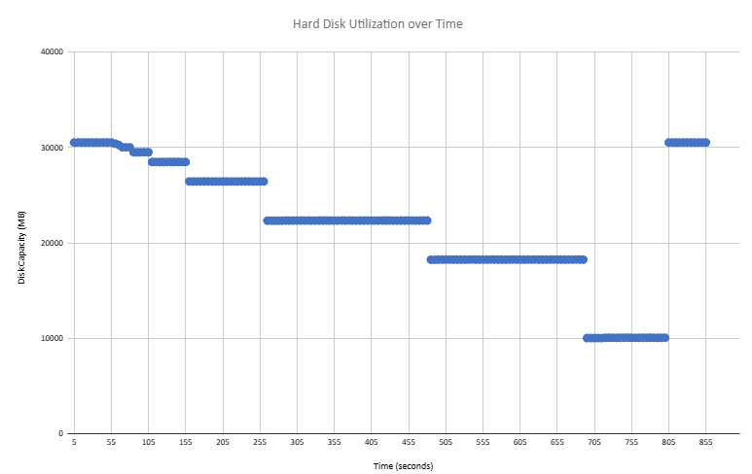

Describe what the hard disk utilization plot shows in 1-2 sentences.

Potential things to write about: How similar (or not) were the transmit and receive data rates? Could you see any patterns in how the data rates changed over time? Were there any interesting patterns in the hard disk access rates or hard disk utilization?

Summary and Lessons Learned
Write 3-4 sentences that describes whether or not the VM you used had enough computing resources (CPU, memory, network capacity, and disk) to handle the mix of application processes that were running and what lessons you learned while working as a team on this project.

